**Experiment Name#01:** Linux setup (Mint-17.3)

**Aim and Objectives:**

The purpose of this lab is to provide an introduction to Linux environment and  how to install Linux Mint -17.3 in Linux system.

* To implement
* To examine the Linux process model and illustrate how Linux schedules processes and provides interprocess communication.
* To look at memory management in Linux.
* To explore how Linux implements file systems and manages I/O devices.

**Experiment Setup:**

**Step 1: Shrink HDD Space:**

**1.** Right click on D: partition and select **Shrink Volume** in order to resize the partition.

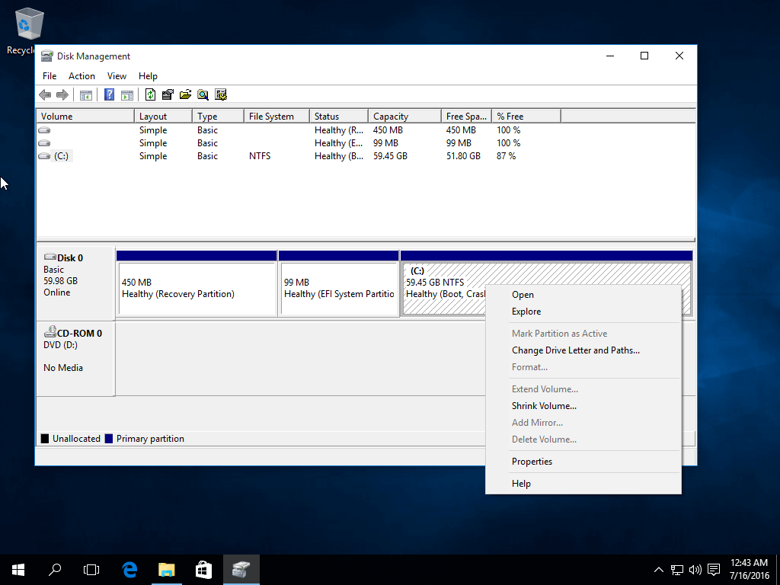

**2.** Use a value best-suited for you, depending on your HDD size, on the amount of space to shrink MB field and hit **Shrink** button to start the process of resizing the partition.

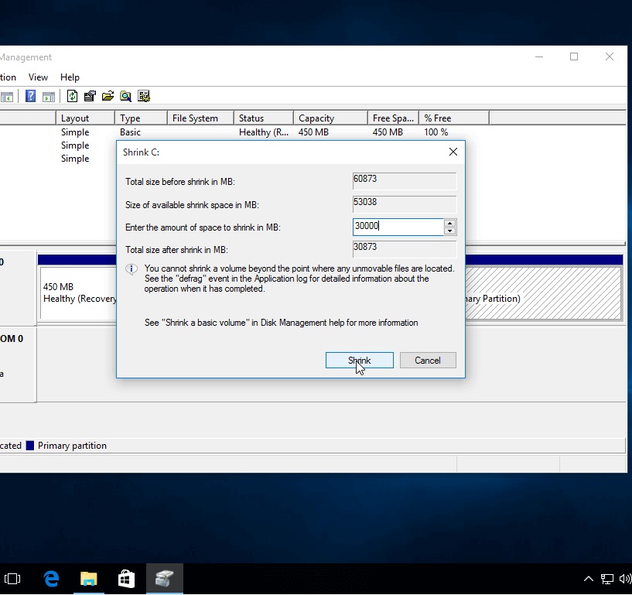

**3.** When the process finishes a new unallocated space will appear on the hard drive.

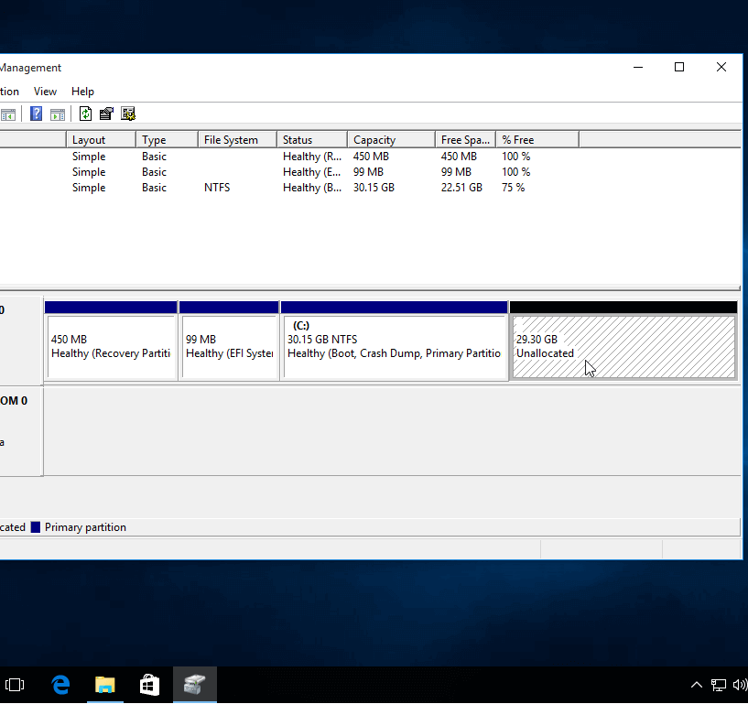

**Step 2: Installation of Linux Mint 17.3:**

**4.** After **reboot**, press the special function key and instruct the machine firmware (**UEFI**) to boot-up from the appropriate DVD or USB drive (the special function keys usually are F12).

Wait until the system loads into **RAM** in order to run in live-mode and open the installer by double clicking on **Install Linux Mint** icon.

Choose the language you wish to perform the installation and click on **Continue** button to proceed further.

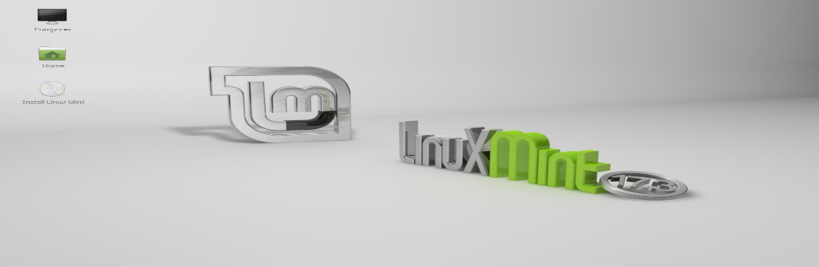

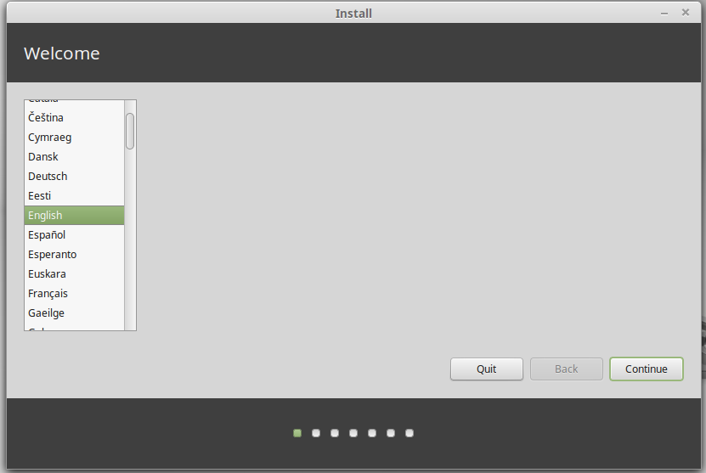

**5.** On the next screen hit on **Continue** button to proceed further. Third-party software can be automatically download and installed on this step by checking the check-box.

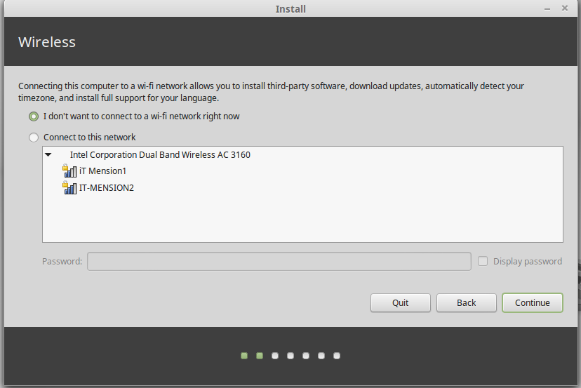

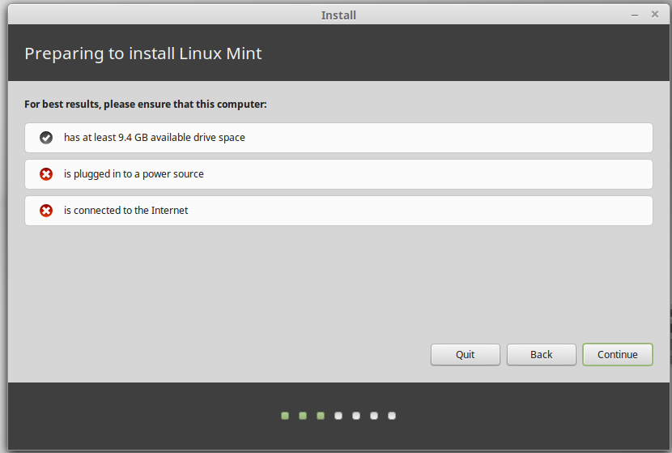

**6.** At the next screen you can choose the **Installation Type**. If **Windows Boot** manager is automatically detected you can choose to **Install Linux Mint** alongside **Windows Boot Manager**. This option ensures that the HDD will be automatically partitioned by the installer without any data loss.

The second option, **Erase disk and install Ubuntu**, should be avoided for dual-boot because is potentially dangerous and will wipe-out your disk.

For a more flexible partition layout you should go with **Something else** option and hit on **Continue** button to proceed further.

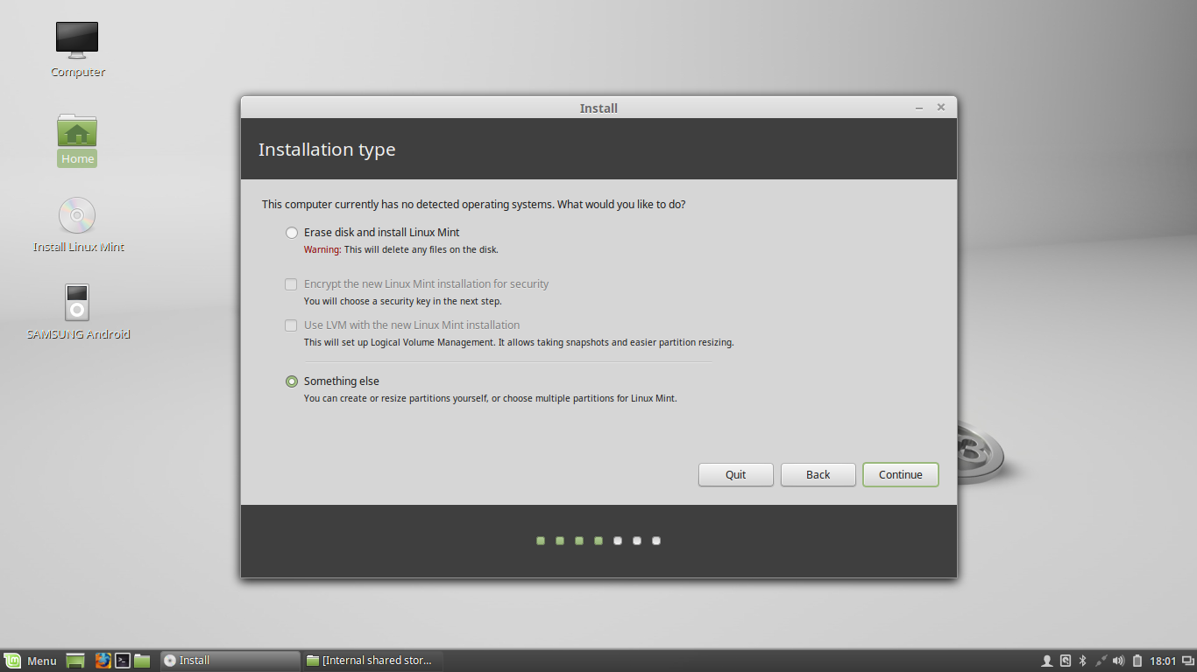

7. Now let’s create the partition layout for Linux Mint 17.3. I would recommend that you create three partitions, one for / (root), one for /home accounts data and one partition for swap.

First create the swap partition. Select the free space and hit on the + icon from below. On this partition use the following settings and hit OK to create the partition:

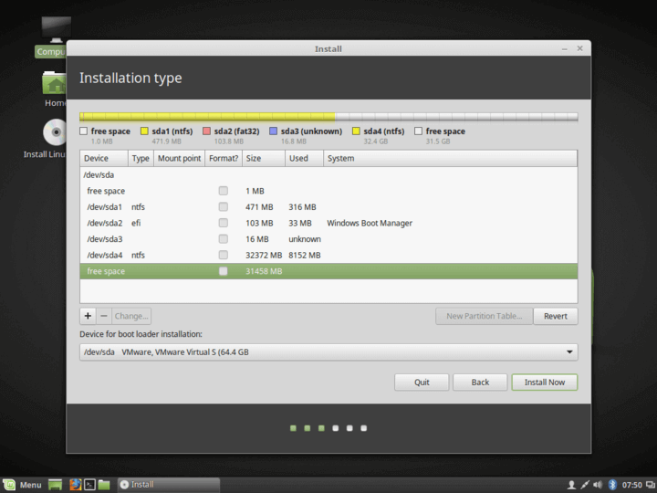

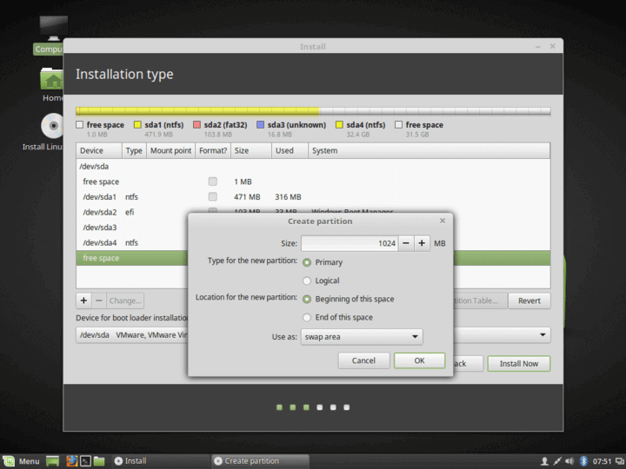

**8.** Using the same steps as above create the /(root) partition with the below settings:

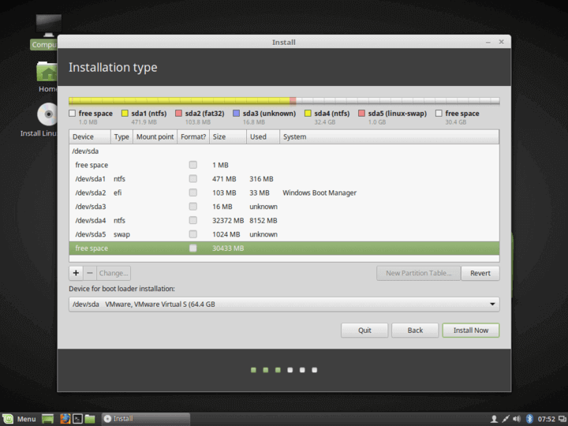

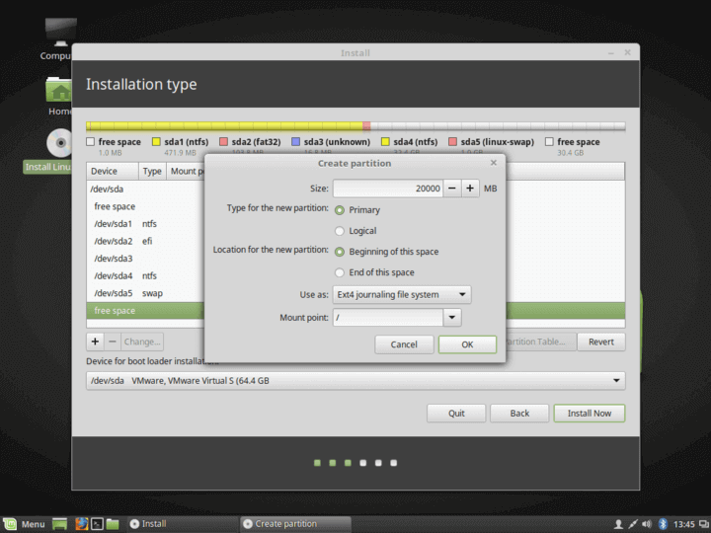

**9.** Finally, create the **home** slice with the below settings (use all the available free space to create home partition).

**Home** partition is the place where all documents for user accounts will be stored by default, except the **root** account. In case of a system failure you can reinstall the operating system for scratch without touching or losing the settings and documents of all users.

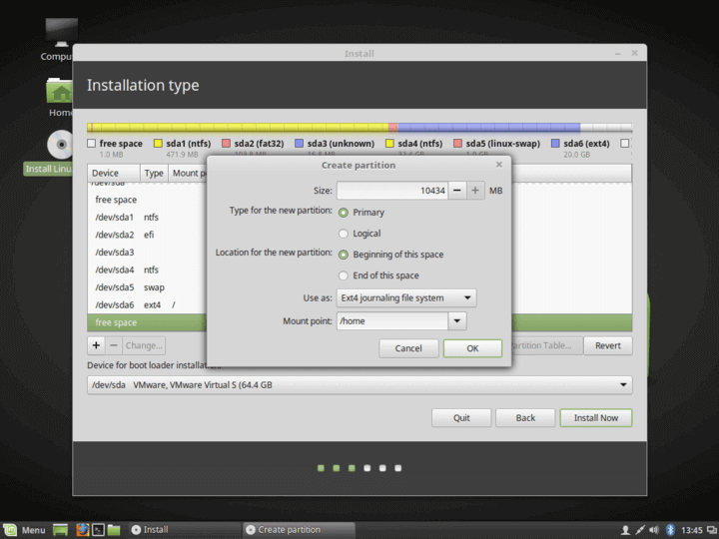

**10.** After finishing creating the partition layout, select **Windows Boot Manager** as the device for installing the Grub boot loader and hit on **Install Now** button in order to commit changes to disk and proceed with the installation.

Next a new pop-up window will ask you if you agree with committing changes to disk. Hit on **Continue** to accept changes and the installer will now start to write changes to disk.

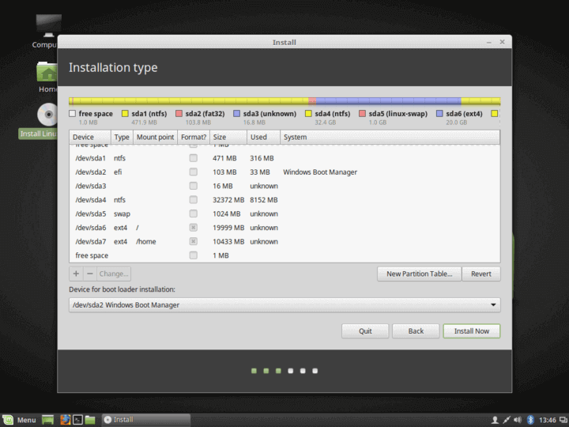

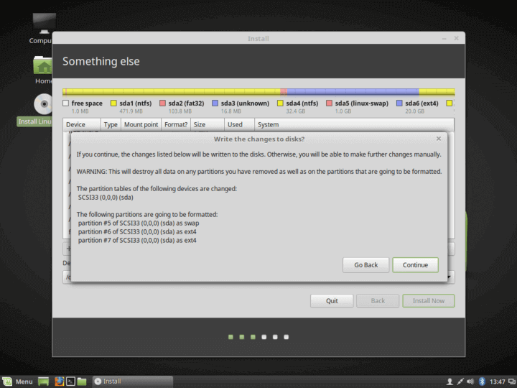

**11.** On the next screen choose your nearest physical location from the map and hit **Continue**.

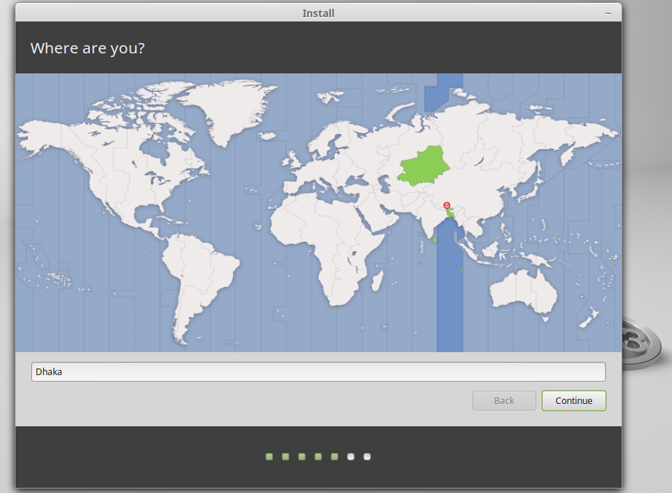

**12.** Next you should select your **keyboard** layout and click on **Continue** button.

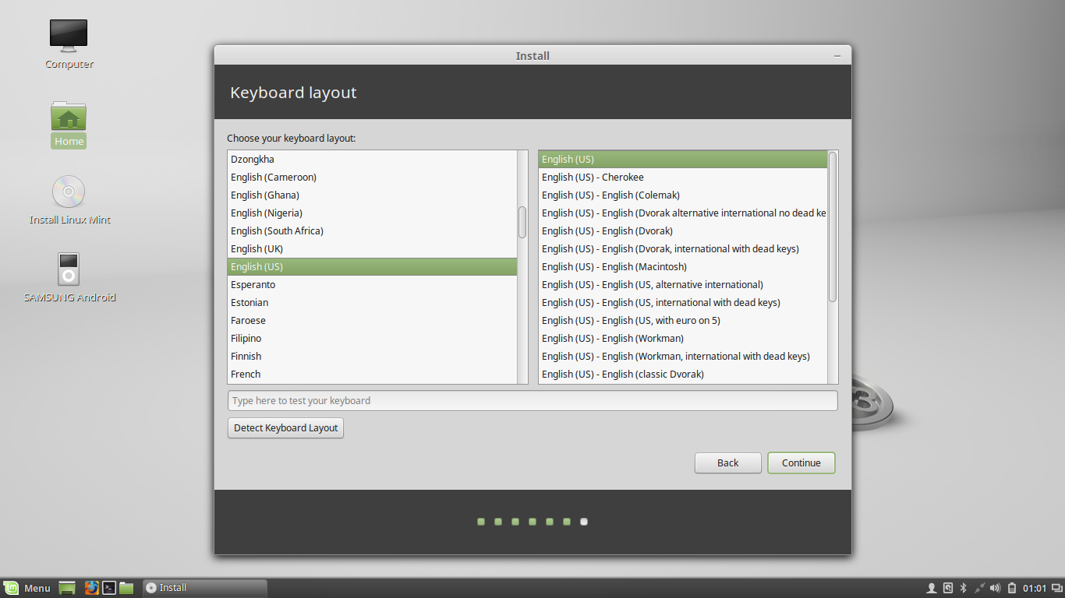

**13.** Enter a **username** and a **password** for the first account with root privileges, choose your system **hostname** by filling the computer’s name field with a descriptive value and hit **Continue** to finalize the installation process.

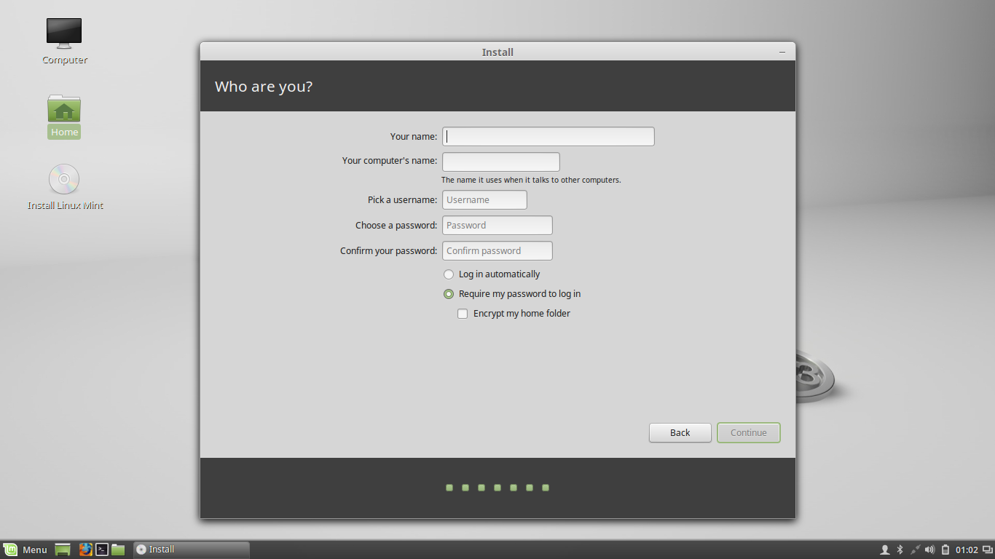

**14.** The installation process will take a while and when it reaches the final step it will ask you to hit on **Restart Now** button to complete the installation.

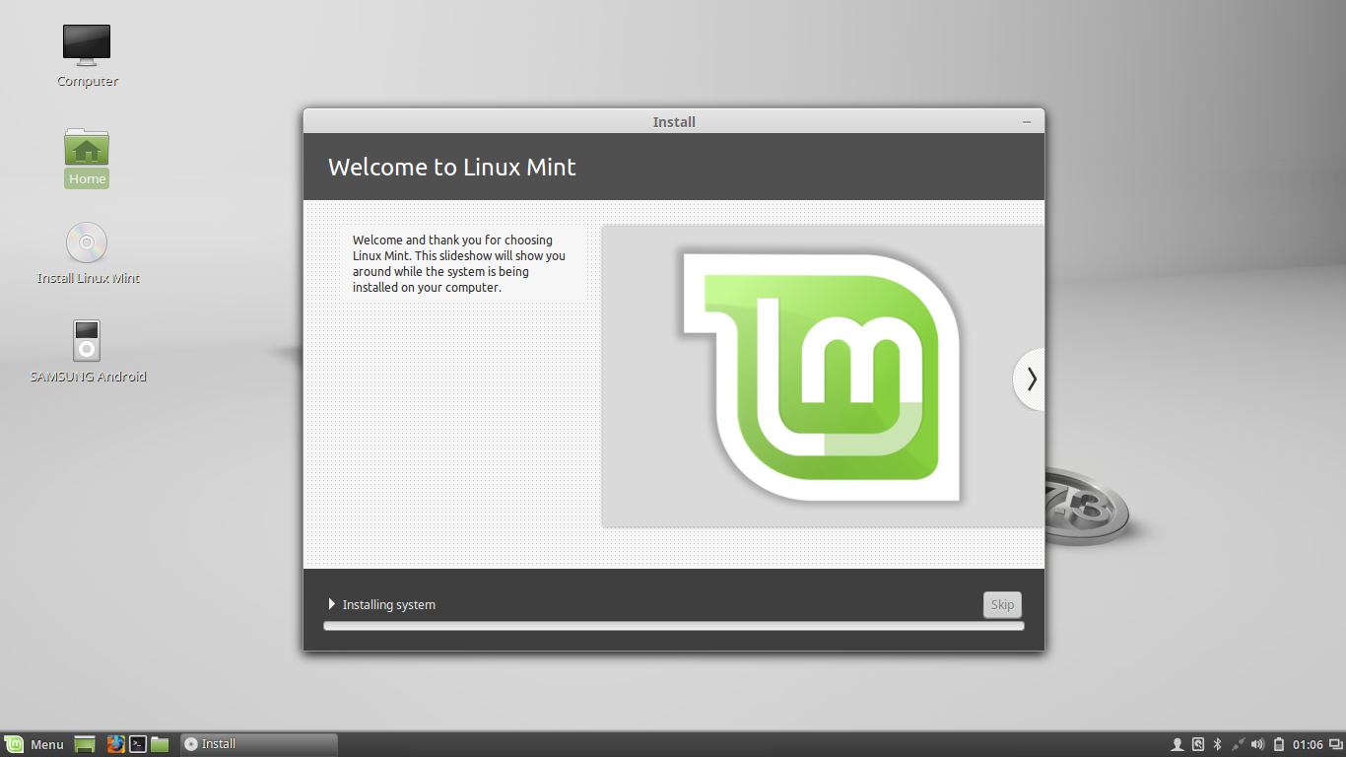

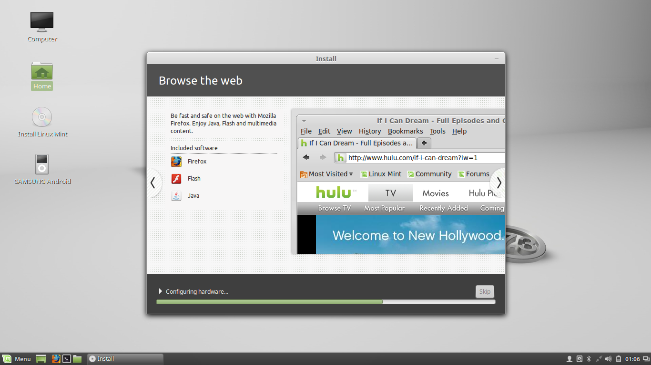

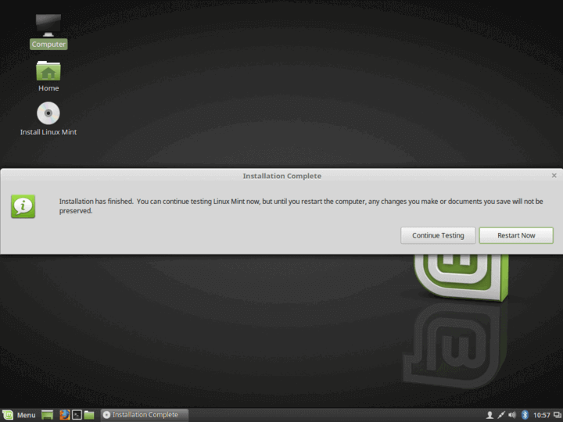

**Conclusion:** In this lab, we have to learn about how to install Linux Mint-17.3.We have successfully done it without any troubling. It helps us to make more efficient of the future in Linux operating system